useActionState() is a React Hook introduced in React 19 that helps you manage the result of an action, such as submitting a login form, registering a user, or saving a profile.
it shows how React can manage form submission state without requiring you to write all the state-management logic yourself.

Why do we need useActionState()?
Imagine you are building a login form.

When a user clicks Login, you need to:
- Read the username and password.
- Validate the credentials.
- Call an API.
- Display success or error messages.
- Prevent duplicate submissions while processing.
- Update the UI based on the result.

Traditionally, you might write code like this:

const [loading, setLoading] = useState(false);
const [error, setError] = useState("");
const [user, setUser] = useState(null);

const handleLogin = async () => {
setLoading(true);
setError("");

try {
const result = await loginAPI();
setUser(result);
} catch (error) {
setError("Login failed");
} finally {
setLoading(false);
}
};

This works, but you have to manage several state variables and their updates manually.

useActionState() lets you organize the action and its returned state together. React updates the state with the result returned by your action

Syntax of useActionState()

const [state, formAction, isPending] = useActionState(actionFunction, initialState);

There are three returned values.

1. state
Stores the latest value returned by your action. It can contain success messages, validation errors, or user data.

2. formAction
A function you pass to a form's action prop. React calls your action when the form is submitted.

3. isPending
A boolean indicating whether the action is currently pending. Use it to show a loading message or disable the submit button.

The initial state is the second argument you pass to useActionState().
const initialState = {
message: "",
success: false
};

The first argument is the action function that receives the previous state and the submitted form data.

Real-time example: Login form
Let's build a login form similar to a real application.
Requirements:
- Username must be admin.
- Password must be 123.
- Display an error message for invalid credentials.
- Display a success message for valid credentials.
- Show Logging in... while the action is running.

This example simulates login validation in the browser. A real application should validate credentials through a backend API.

Login.jsx

import { useActionState } from "react";

const initialState = {
message: "",
success: false,
};

async function loginAction(previousState, formData) {
// Read values from the submitted form
const username = formData.get("username");
const password = formData.get("password");

// Simulate API delay
await new Promise((resolve) => setTimeout(resolve, 1000));

// Validate credentials
if (username === "admin" && password === "123") {
return {
message: "Login successful!",
success: true,
};
}

// Return an error state
return {
message: "Invalid username or password.",
success: false,
};
}

export default function Login() {
const [state, formAction, isPending] = useActionState(
loginAction,
initialState
);

return (
<div>
<h2>Login</h2>

<form action={formAction}>
<div>
<label>Username</label>
<input
type="text"
name="username"
required
/>
</div>

<div>
<label>Password</label>
<input
type="password"
name="password"
required
/>
</div>

<button type="submit" disabled={isPending}>
{isPending ? "Logging in..." : "Login"}
</button>
</form>

{state.message && (
<p style={{
color: state.success ? "green" : "red"
}}>
{state.message}
</p>
)}
</div>
);
}

Explanation

Define the initial state
const initialState = {
message: "",
success: false,
};

Initially, there is no message, and the login has not succeeded.

Create the action function
async function loginAction(previousState, formData) {
const username = formData.get("username");
const password = formData.get("password");

// Validate and return the result
}

There are two parameters:
previousState: the state returned by the previous action, or the initial state on the first submission.

formData: contains the submitted form fields.

For example:
formData.get("username");
formData.get("password");

These works because the inputs have name="username" and name="password".
Notice that previousState isn't used in this particular example. You can still include it in the function signature.

Connect the Hook to the action
const [state, formAction, isPending] = useActionState(
loginAction,
initialState
);
React connects loginAction with the form. You don't need to manually call loginAction() from an onSubmit handler.

Connect the form
<form action={formAction}>
When the user submits the form, React calls the action and provides the submitted FormData.

Display the result
{state.message && <p>{state.message}</p>}
Whatever object the action returns becomes the next state.

Show the loading state
<button disabled={isPending}>
{isPending ? "Logging in..." : "Login"}
</button>

While the asynchronous action is running, isPending is true. When it finishes, React updates the returned state and the button label.

What happens internally when you submit the form?

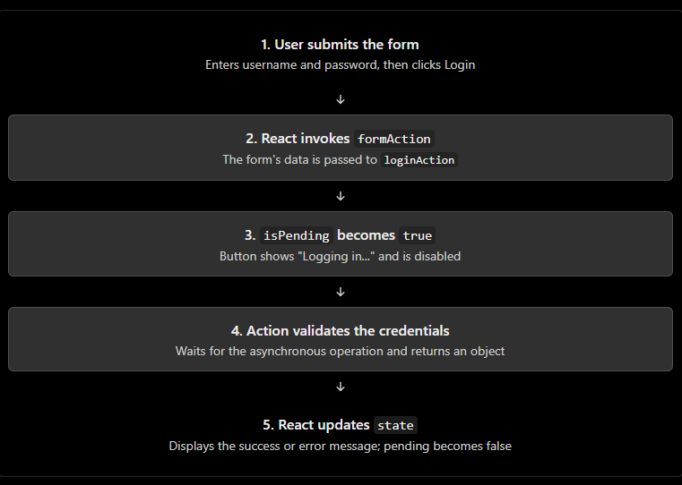

Understanding previousState in detail
Suppose your action is:
async function loginAction(previousState, formData) {
console.log(previousState);

return {
message: "Login successful!",
success: true,
};
}

On the first submission, previousState is:
{
message: "",
success: false
}

After the action returns, the next submission receives:
{
message: "Login successful!",
success: true
}

The important rule is:
The return value of one action becomes the previous state for the next action.
You can use this to retain information, such as a submission count or the last result.

Difference between useActionState, useState and useReducer

Feature | useState | useReducer | useActionState
Main purpose | Manage component state | Manage state transitions | Manage action results
Async actions | You manage them yourself | You manage them separately | Action function can be async
Pending state | Manage manually | Manage manually | Built-in isPending
Form integration | Usually use handlers | Usually use handlers | Can use a form's action prop
Typical example | Toggle, input value | Complex UI state | Submit, validate, save

Form Actions
In React 19, Form Actions let you handle form submissions by passing a JavaScript function to the form's action prop. React can manage the submission lifecycle, integrate with pending states, and work with hooks such as useActionState and useFormStatus.

What are Form Actions?
Traditionally, we handle a form submission using onSubmit and useState.
Traditional approach (React 16–18 and later):

import { useState } from "react";

function Login() {
const [username, setUsername] = useState("");

const handleSubmit = (event) => {
event.preventDefault();
console.log("Username:", username);
};

return (
<form onSubmit={handleSubmit}>
<input
value={username}
onChange={(e) => setUsername(e.target.value)}
placeholder="Enter username"
/>

<button type="submit">Login</button>
</form>
);
}

export default Login;

Here, we manually:
- Prevent the browser's default form submission.
- Store the input value in state.
- Write a submit handler.
- Process the form data.

React 19 Form Actions approach:

function handleLogin(formData) {
const username = formData.get("username");
console.log("Username:", username);
}

function Login() {
return (
<form action={handleLogin}>
<input name="username" placeholder="Enter username" />
<button type="submit">Login</button>
</form>
);
}

export default Login;
Notice the important differences:
- action={handleLogin} connects the form to a function.
- name="username" makes the input available in the submitted form data.
- React passes a FormData object to the action function.
- You don't need an onSubmit handler or event.preventDefault() for this pattern.

useFormStatus()
useFormStatus() is a React hook that helps you check the status of a form submission, such as whether the form is currently submitting.

For example, when a user clicks the Login button, you can:
- Disable the button while the form is submitting.
- Display Logging in... instead of Login.
- Prevent accidental repeated submissions.
- Show a loading indicator while an action is running.
It is especially useful with React 19 form Actions.

Syntax
import { useFormStatus } from "react-dom";

const { pending, data, method, action } = useFormStatus();

Here is what each property means:
Property | Meaning
pending | true while the parent form's submission is pending.
data | The submitted form data, or null if no submission is pending.
method | The form's submission method, such as "get" or "post".
action | The form action function handling the submission, or null when applicable.

Example

import { useFormStatus } from "react-dom";
function LoginButton() {
const { pending } = useFormStatus();
return (
<button type="submit" disabled={pending}>
{pending ? "Logging in..." : "Login"}
</button>
);
}

export default function LoginForm() {
async function handleLogin(formData) {
const username = formData.get("username");
const password = formData.get("password");

console.log(username, password);

// Simulate an API request
await new Promise((resolve) =>
setTimeout(resolve, 2000)
);

alert("Login request completed");
}

return (
<form action={handleLogin}>
<input
type="text"
name="username"
placeholder="Enter username"
required
/>
<input
type="password"
name="password"
placeholder="Enter password"
required
/>
<LoginButton />
</form>
);
}

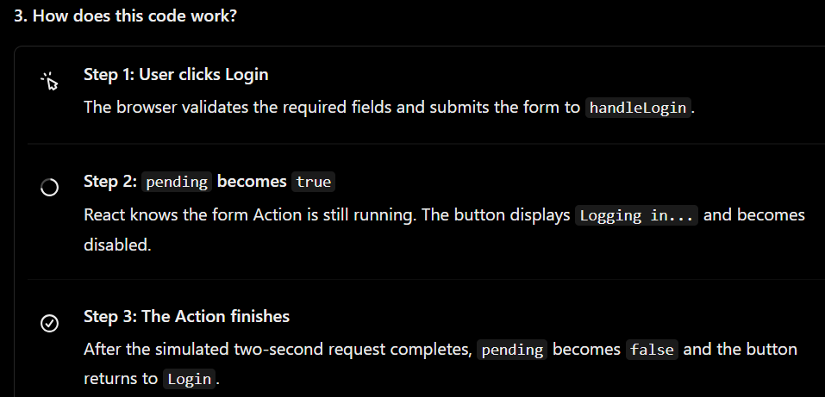
The important line is:
const { pending } = useFormStatus();

And this conditional rendering uses it:
{pending ? "Logging in..." : "Login"}

This is a ternary operator: if pending is true, show Logging in...; otherwise, show Login.
Important: This example only simulates a login request. A real login should validate credentials on the server and handle authentication securely.

useFormStatus() reads the status of a parent form, not a form returned by the same component

useFormStatus() vs useActionState()
Since you are learning React form Actions, it is useful to understand how these two hooks differ.
Feature | useFormStatus() | useActionState()
Main purpose | Read the parent form's submission status | Manage the result/state of an Action
Returns | Form status properties | [state, action, isPending]
Shows loading state | Yes | Yes, through isPending
Manages error or success messages | Not by itself | Yes, when the Action returns that state
Requires a parent form | Yes, to read its status | No, although commonly used with a form

useFormStatus() is a React DOM hook introduced in React 19 that provides information about the submission status of a parent form. Its pending property is commonly used to disable submit buttons and display loading indicators while a form Action is executing. It must be called inside a component rendered within the form whose status we want to observe.

Remember: useFormStatus() observes the form status; useActionState() manages Action-related state.

